Nondegenerate Triangle

Definition
# Source: AI Source: Provided by: [Data Path: Persons Table -> ID Column: 1, Name_En Column: Motasem Essam] -> From: [ChatGPT] on [7/25/2026]
A Nondegenerate Triangle is a triangle whose three vertices are not collinear, so it has a positive area and three genuine interior angles.
A nondegenerate triangle is an ordinary triangle in Euclidean geometry, as opposed to a degenerate triangle, in which the three vertices lie on a single straight line and the area is zero.

Simple Definition
# Source: AI Source: Provided by: [Data Path: Persons Table -> ID Column: 1, Name_En Column: Motasem Essam] -> From: [ChatGPT] on [7/25/2026]
A nondegenerate triangle is a triangle that has three non-collinear vertices, positive area, and side lengths satisfying the strict triangle inequalities.
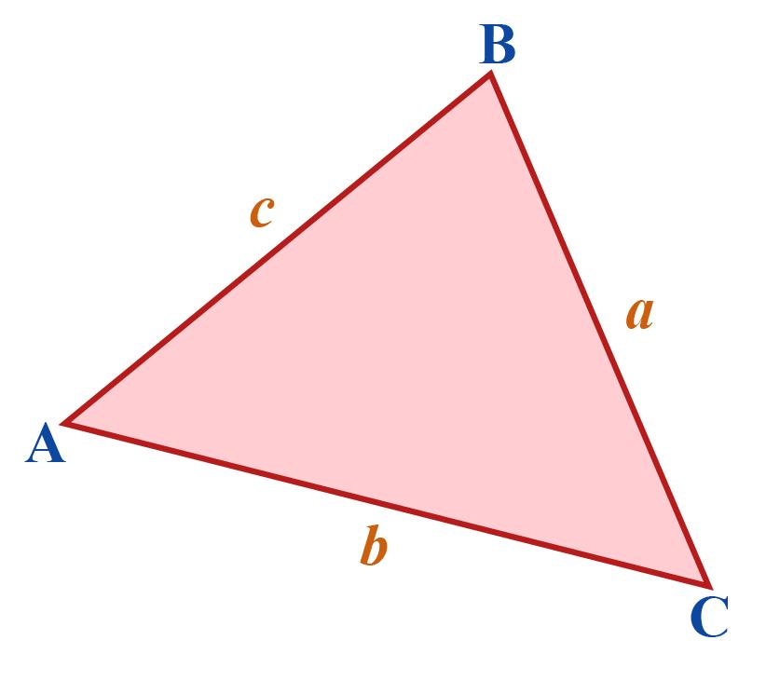
Checking Favorites status
cuemath

Main Classification
# Source: AI Source: Provided by: [Data Path: Persons Table -> ID Column: 1, Name_En Column: Motasem Essam] -> From: [ChatGPT] on [7/25/2026]
Nondegenerate triangles can be classified by their side lengths or their interior angles. These classifications overlap: for example, an equilateral triangle is also acute.

1. Equilateral Triangle
# Source: AI Source: Provided by: [Data Path: Persons Table -> ID Column: 1, Name_En Column: Motasem Essam] -> From: [ChatGPT] on [7/25/2026]
All three sides are equal, and each interior angle is ${60}^{∘}$.
Example: $AB=BC=CA=5$.
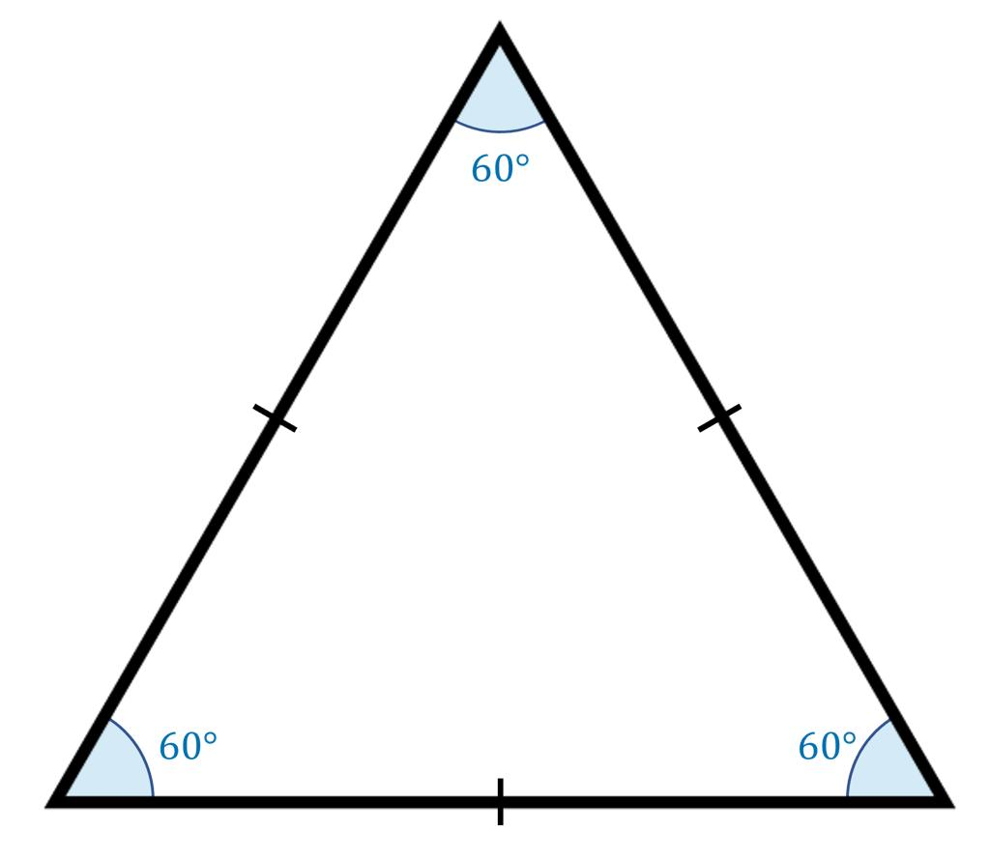

2. Isosceles Triangle
# Source: AI Source: Provided by: [Data Path: Persons Table -> ID Column: 1, Name_En Column: Motasem Essam] -> From: [ChatGPT] on [7/25/2026]
At least two sides are equal under the inclusive definition commonly used in modern mathematics.
Example: $AB=AC=5, BC=6$.
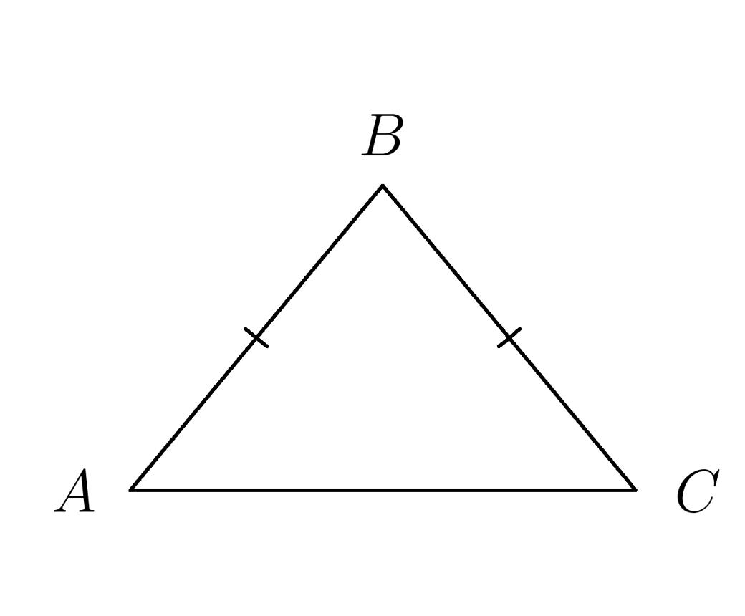

3. Scalene Triangle
# Source: AI Source: Provided by: [Data Path: Persons Table -> ID Column: 1, Name_En Column: Motasem Essam] -> From: [ChatGPT] on [7/25/2026]
All three sides have different lengths.
Example: $AB=4, BC=5, CA=6$.
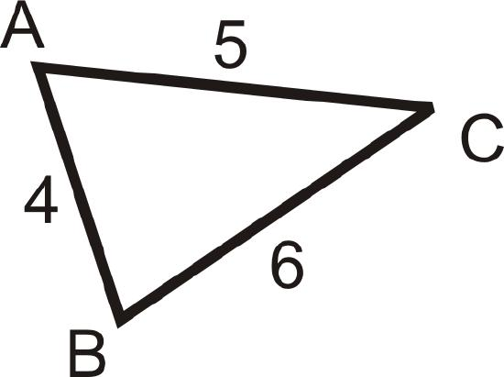

4. Acute Triangle
# Source: AI Source: Provided by: [Data Path: Persons Table -> ID Column: 1, Name_En Column: Motasem Essam] -> From: [ChatGPT] on [7/25/2026]
All three interior angles are less than ${90}^{∘}$.
Example: ${50}^{∘}, {60}^{∘}, {70}^{∘}$.
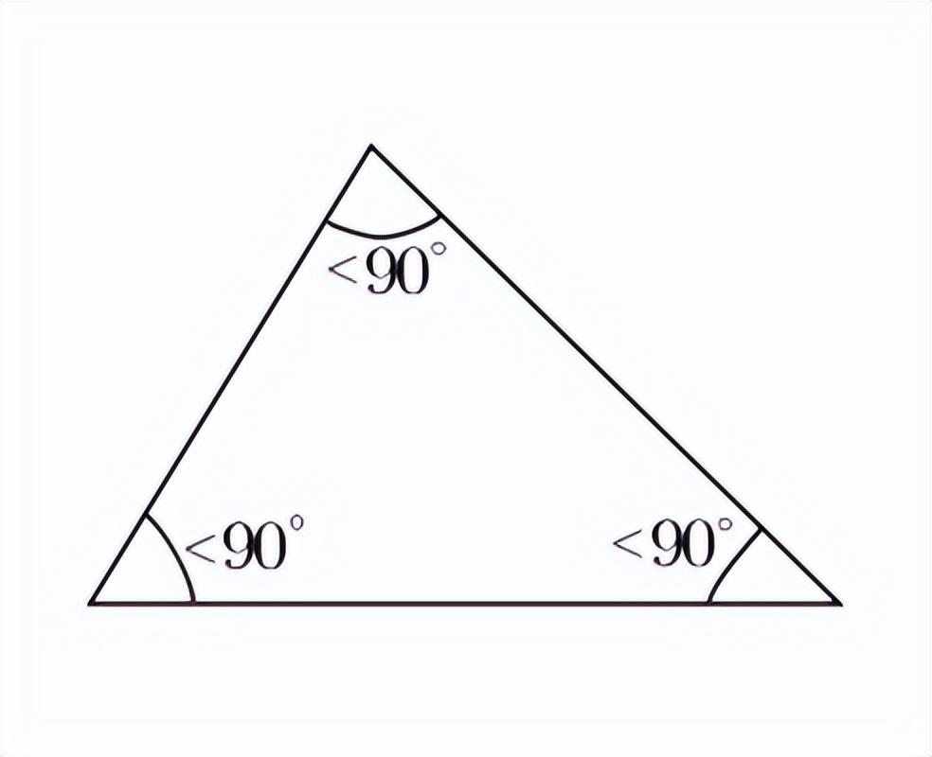

5. Right Triangle
# Source: AI Source: Provided by: [Data Path: Persons Table -> ID Column: 1, Name_En Column: Motasem Essam] -> From: [ChatGPT] on [7/25/2026]
Exactly one interior angle is ${90}^{∘}$.
Example: $3, 4, 5$side lengths, with angles approximately ${36.87}^{∘}, {53.13}^{∘}, {90}^{∘}$.
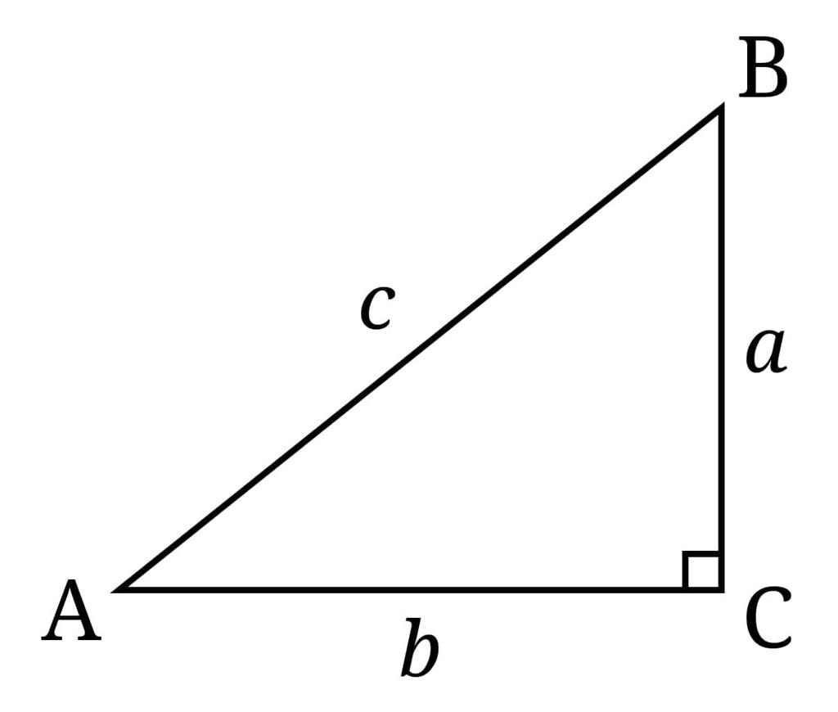

6. Obtuse Triangle
# Source: AI Source: Provided by: [Data Path: Persons Table -> ID Column: 1, Name_En Column: Motasem Essam] -> From: [ChatGPT] on [7/25/2026]
Exactly one interior angle is greater than ${90}^{∘}$.
Example: ${30}^{∘}, {40}^{∘}, {110}^{∘}$.
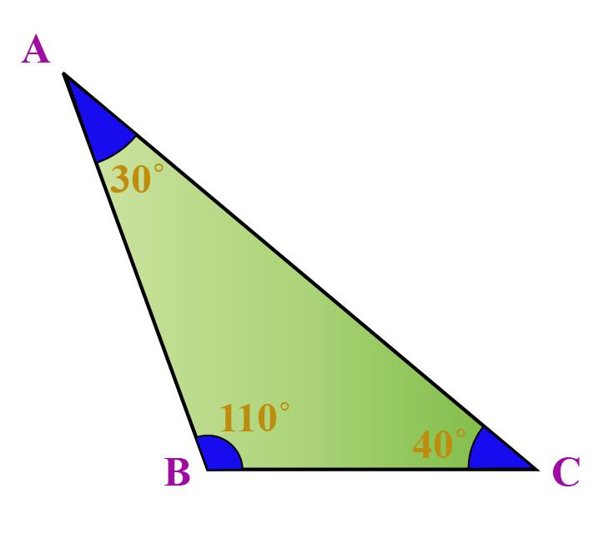

Essential Conditions for a Nondegenerate Triangle

A. Non-collinear vertices
# Source: AI Source: Provided by: [Data Path: Persons Table -> ID Column: 1, Name_En Column: Motasem Essam] -> From: [ChatGPT] on [7/25/2026]
For triangle $△ABC$, the points $A$, $B$, and $C$must not lie on the same straight line.
In coordinate geometry, if the vertices are $A\left(x_{1} , y_{1}\right)$, $B\left(x_{2} , y_{2}\right)$, and $C\left(x_{3} , y_{3}\right)$, they form a nondegenerate triangle exactly when
$$\left(x_{2}-x_{1}\right)\left(y_{3}-y_{1}\right)-\left(y_{2}-y_{1}\right)\left(x_{3}-x_{1}\right)≠0$$

B. Positive area
# Source: AI Source: Provided by: [Data Path: Persons Table -> ID Column: 1, Name_En Column: Motasem Essam] -> From: [ChatGPT] on [7/25/2026]
The triangle must have positive area:
$$K>0$$
Its area can be calculated using the base and perpendicular height:
$$K=\frac{1}{2}bh$$
Here, $b>0$and $h>0$.
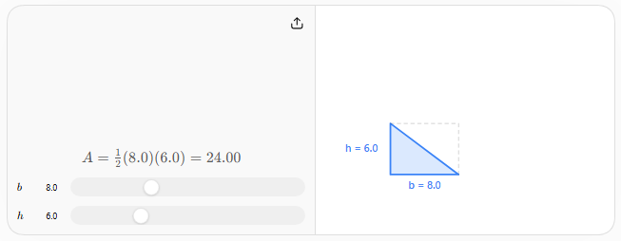

C. Strict triangle inequalities
# Source: AI Source: Provided by: [Data Path: Persons Table -> ID Column: 1, Name_En Column: Motasem Essam] -> From: [ChatGPT] on [7/25/2026]
For side lengths $a$, $b$, and $c$, all three inequalities must hold:
$$a+b>c$$
$$a+c>b$$
$$b+c>a$$
These conditions ensure that the three sides can form a proper triangle rather than a straight-line configuration.
Example:
- $3,4,5$: nondegenerate, because $3+4>5$.
- $3,5,8$: degenerate at the equality limit, because $3+5=8$.
- $2,3,6$: no triangle is possible, because $2+3<6$.

Nondegenerate Triangle vs. Degenerate Triangle
# Source: AI Source: Provided by: [Data Path: Persons Table -> ID Column: 1, Name_En Column: Motasem Essam] -> From: [ChatGPT] on [7/25/2026]
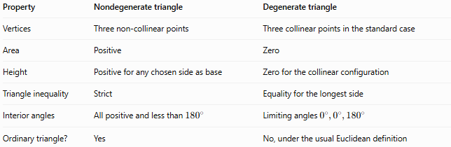
Property | Nondegenerate triangle | Degenerate triangle
Vertices | Three non-collinear points | Three collinear points in the standard case
Area | Positive | Zero
Height | Positive for any chosen side as base | Zero for the collinear configuration
Triangle inequality | Strict | Equality for the longest side
Interior angles | All positive and less than ${180}^{∘}$ | Limiting angles $0^{∘},0^{∘},{180}^{∘}$
Ordinary triangle? | Yes | No, under the usual Euclidean definition

Classification Summary
# Source: AI Source: Provided by: [Data Path: Persons Table -> ID Column: 1, Name_En Column: Motasem Essam] -> From: [ChatGPT] on [7/25/2026]
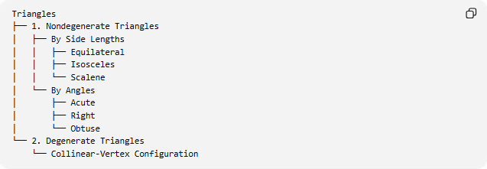
Triangles
├── 1. Nondegenerate Triangles
│ ├── By Side Lengths
│ │ ├── Equilateral
│ │ ├── Isosceles
│ │ └── Scalene
│ └── By Angles
│ ├── Acute
│ ├── Right
│ └── Obtuse
└── 2. Degenerate Triangles
└── Collinear-Vertex Configuration
This is a practical classification by geometric validity and familiar triangle types. The side-based and angle-based categories are not mutually exclusive.

Key Points
# Source: AI Source: Provided by: [Data Path: Persons Table -> ID Column: 1, Name_En Column: Motasem Essam] -> From: [ChatGPT] on [7/25/2026]
- Every nondegenerate triangle has three non-collinear vertices.
- Its area is strictly positive.
- Its interior angles sum to 180∘180^\circ180∘.
- Its side lengths satisfy all three strict triangle inequalities.
- Every ordinary equilateral, isosceles, scalene, acute, right, or obtuse triangle is nondegenerate.

Conclusion
# Source: AI Source: Provided by: [Data Path: Persons Table -> ID Column: 1, Name_En Column: Motasem Essam] -> From: [ChatGPT] on [7/25/2026]
A Nondegenerate Triangle is a valid, ordinary triangle with three non-collinear vertices and positive area. Its defining mathematical distinction from a degenerate triangle is that its side lengths satisfy the strict triangle inequalities, rather than reaching equality.

